Module-1: INTRODUCTION TO ALGORITHMS
  - What is an Algorithm?
An algorithm constitutes a sequence of steps aimed at accomplishing a particular task. As an illustration, let's consider the task of preparing a cup of tea. The algorithm involves the following steps:
- Pour water and milk into the kettle.
- Boil the mixture and add tea leaves.
- Introduce sugar and subsequently serve the tea in a cup.
In general, an algorithm can be defined as a set of steps to complete a task, with the level of precision required to enable execution by a computer. However, achieving this level of precision can be challenging for machines, as evidenced by the difficulty in specifying exact quantities of water, milk, etc., in the aforementioned tea-making algorithm.
These algorithms are designed to operate on computers or computational devices. For instance, our smartphones feature algorithms such as GPS and Google Hangouts. The GPS employs a shortest path algorithm, while online shopping relies on cryptography, specifically utilizing the RSA algorithm.
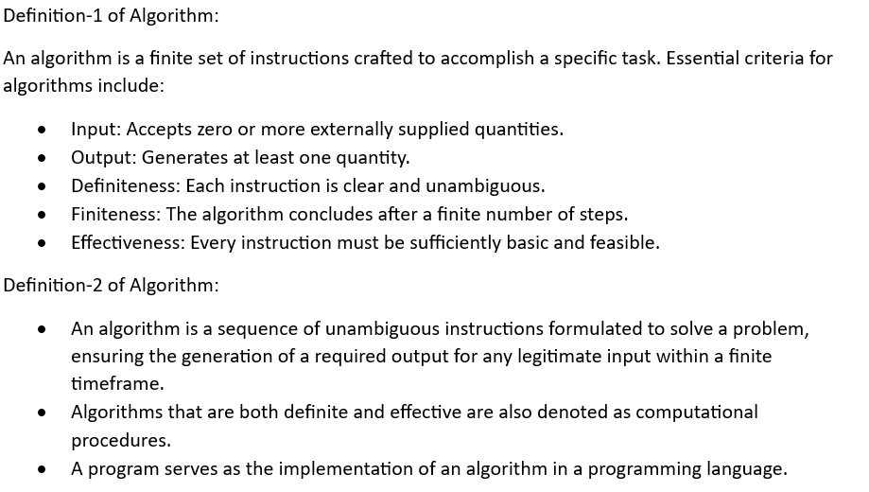
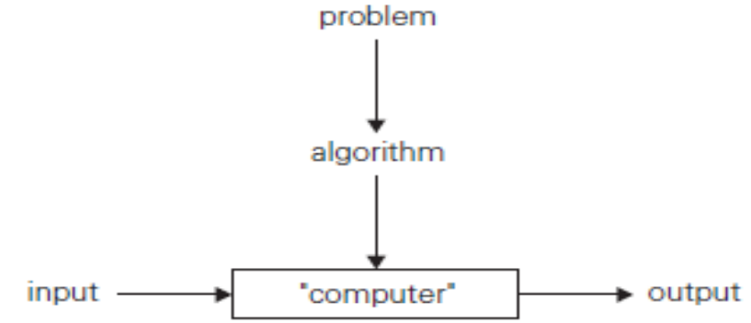
Problem Solving Algorithm Steps:
- Define the problem.
- Design or specify the algorithm.
- Analyze the algorithm.
- Implement the solution.
- Perform testing.
- Maintenance
Step 1: Define the problem
- Determine the task to be accomplished. Example: Calculate the average of grades for a given student.
Step 2: Design or specify the algorithm
- Describe the solution using natural language, pseudo-code, diagrams, etc.
Step 3: Analyze the algorithm
- Assess the algorithm's space complexity (required space) and time complexity (execution time).
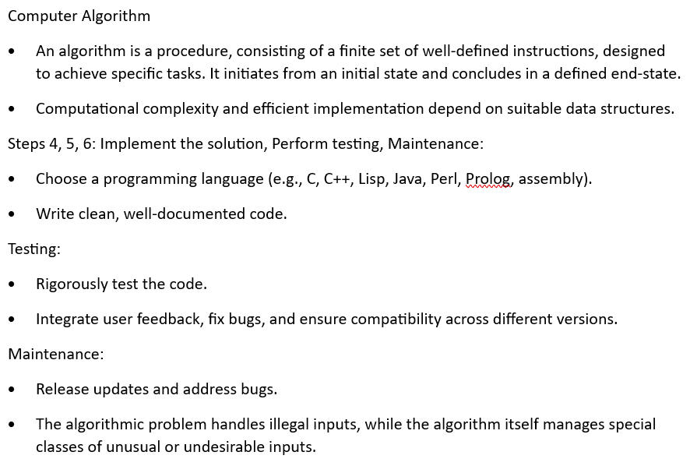

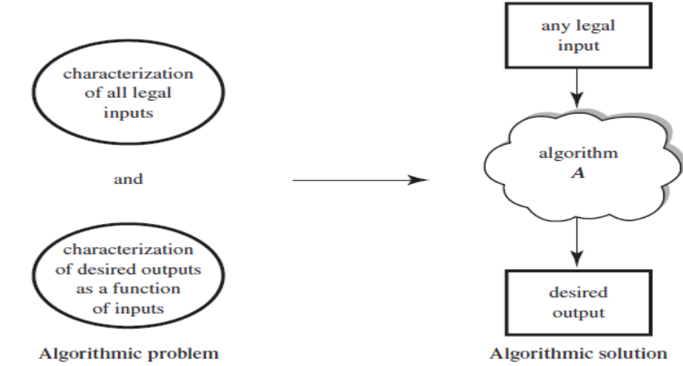
Four Distinct Areas of Algorithmic Study:
- Algorithm Devising Techniques:
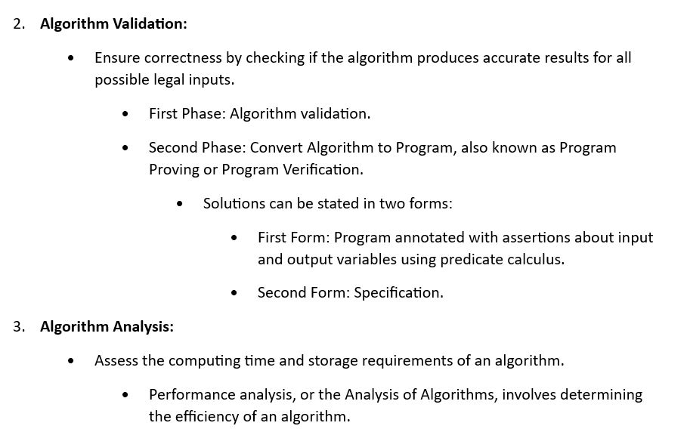
  - Focus on developing algorithms using techniques like Divide & Conquer, Branch and Bound, and Dynamic Programming.
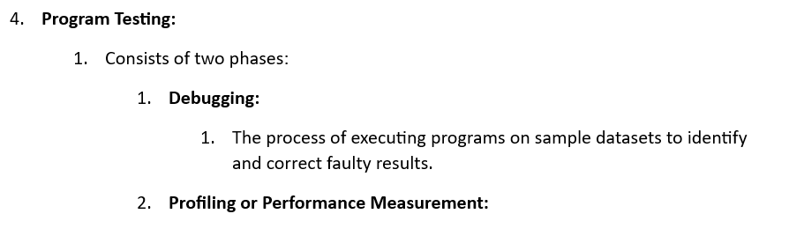

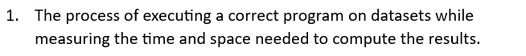
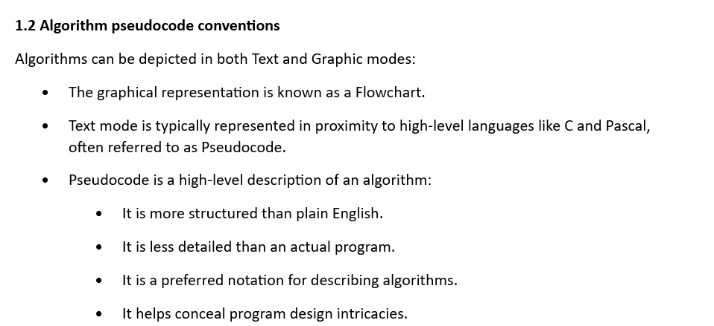
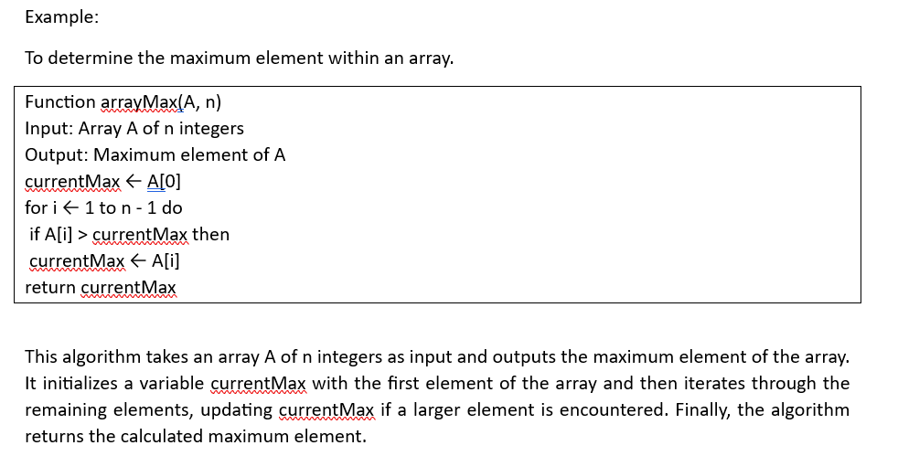
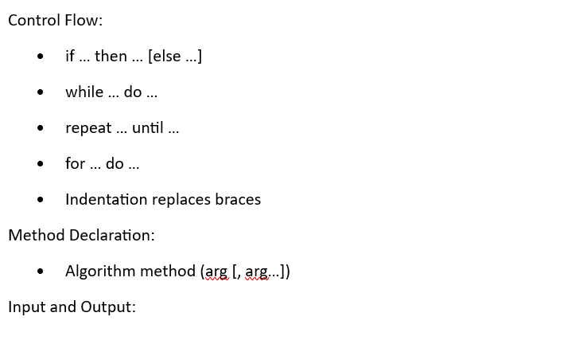
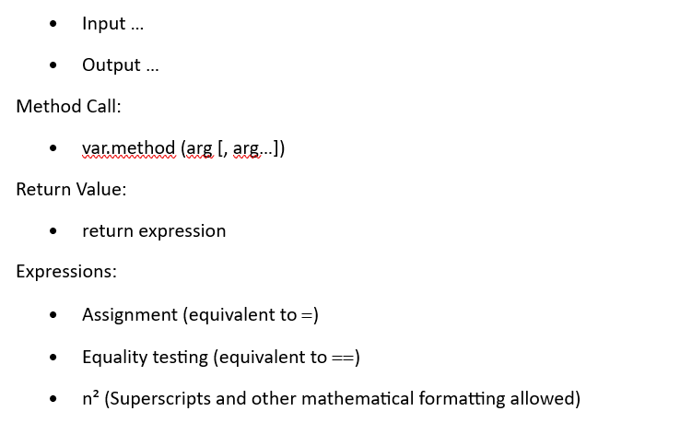
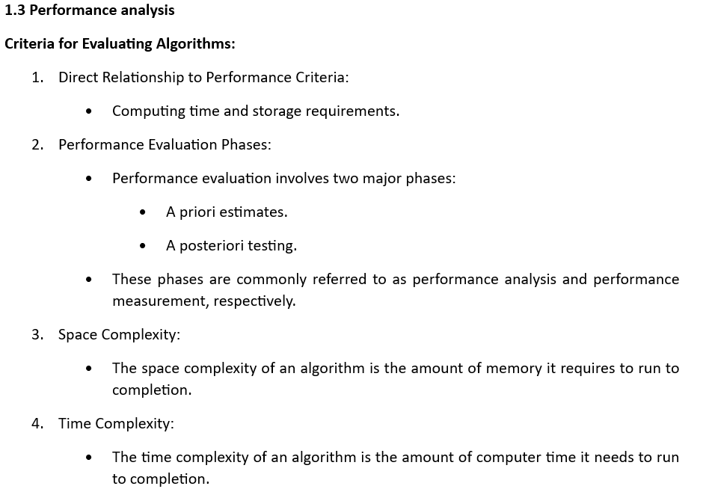
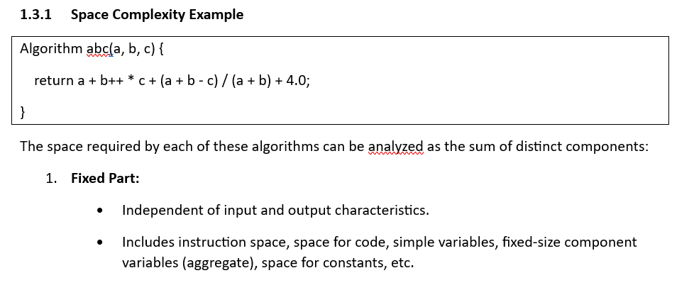
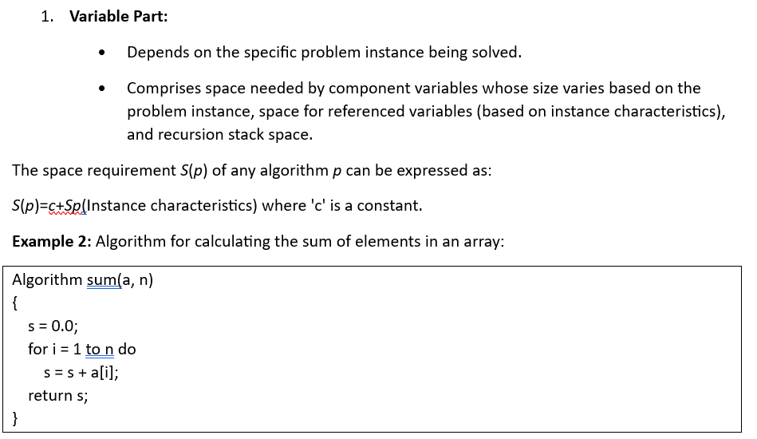
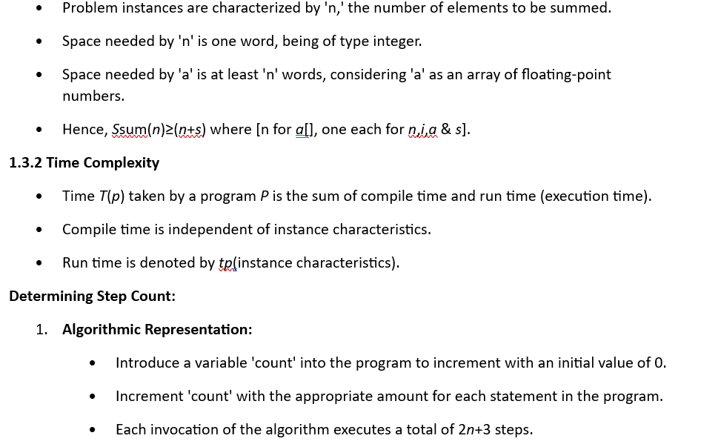
- Table Method:
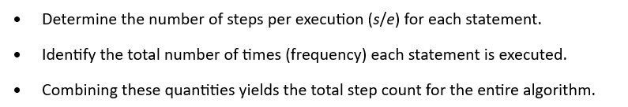
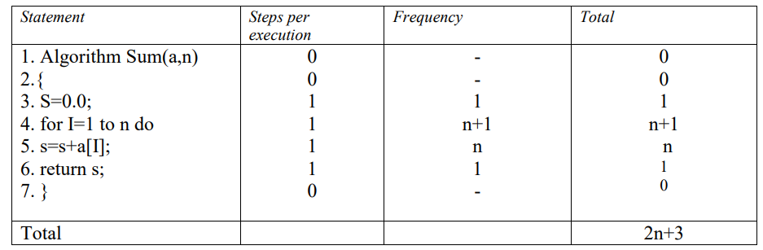
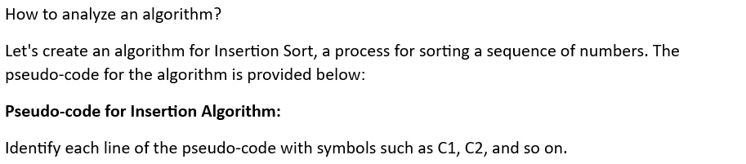
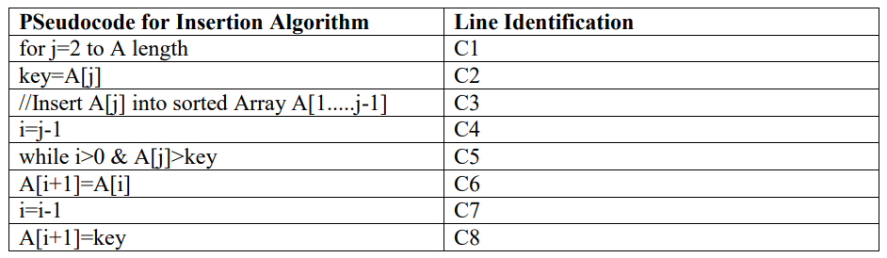
Let Ci​ represent the cost of the ith line. As comment lines do not contribute to any cost, C3​=0.
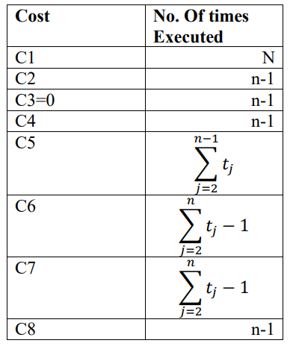
The algorithm's execution time is:
The time complexity of the algorithm is expressed as:
T(n)=C1n+C2(n−1)+O(n−1)+C4(n−1)+C5+C6+C7+C8(n−1)
Best case:
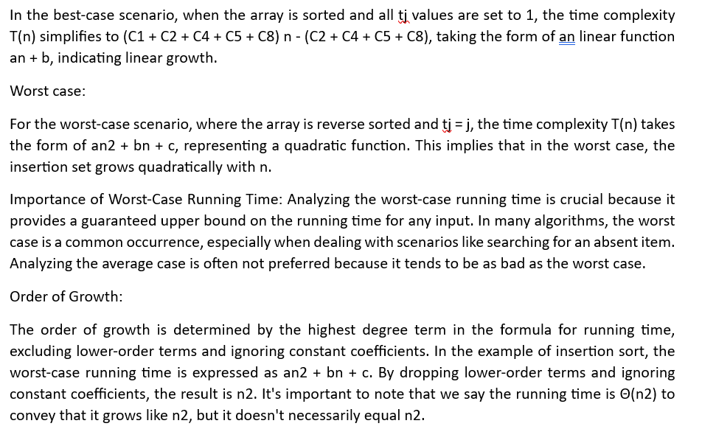
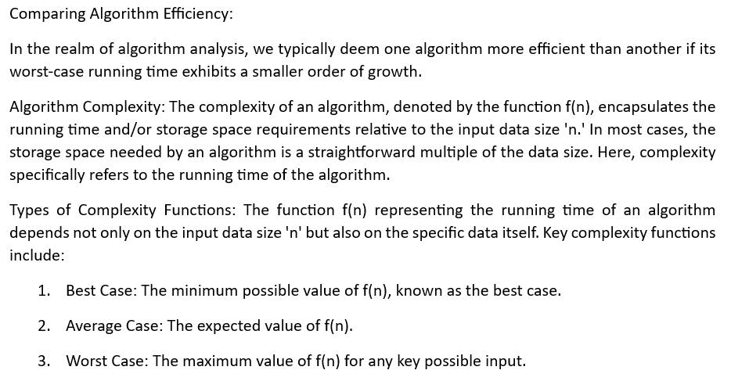
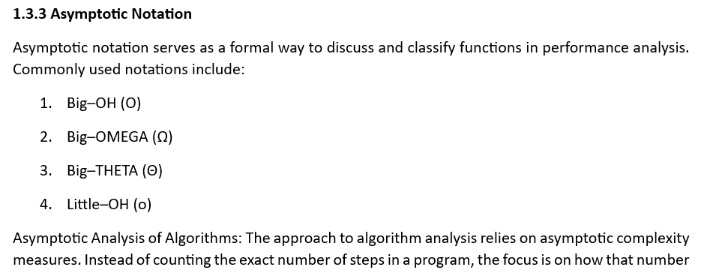
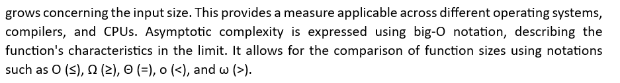
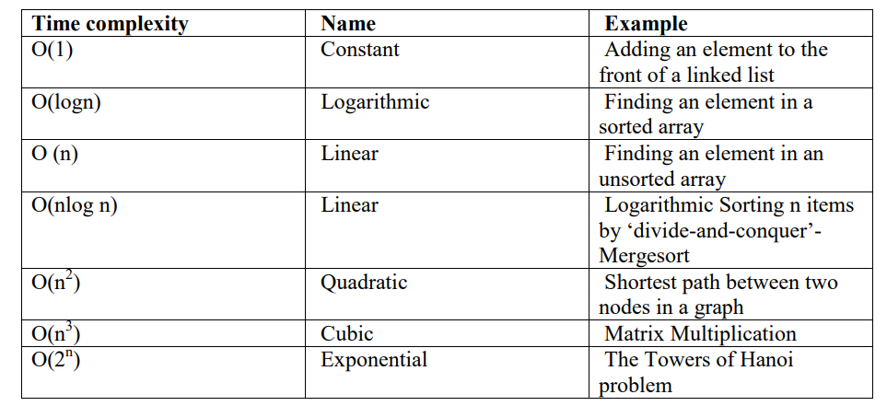
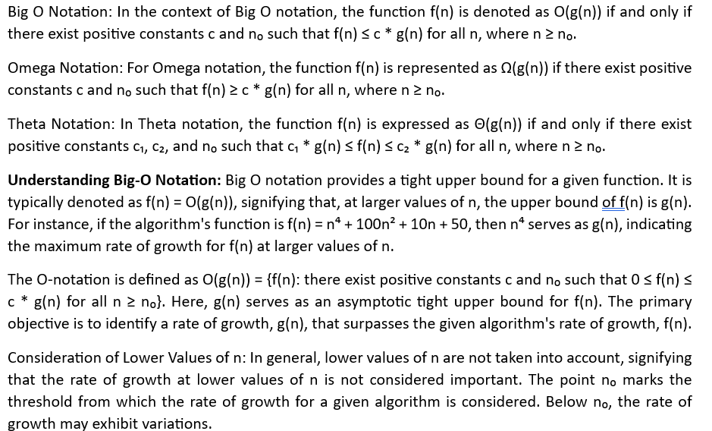
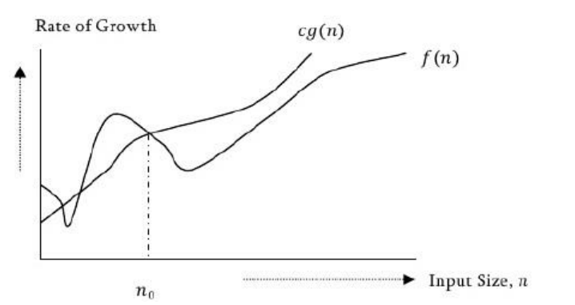
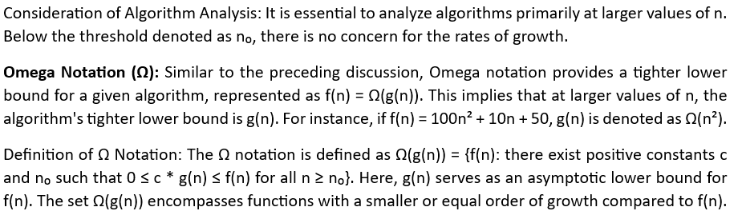
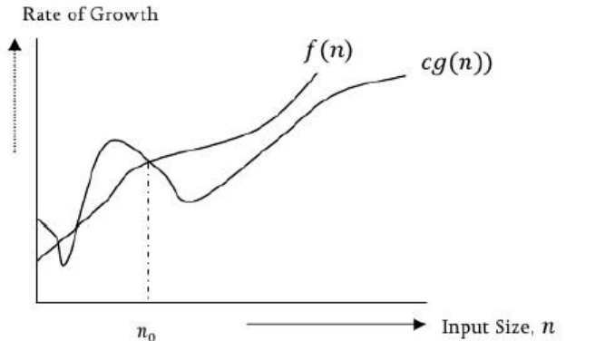
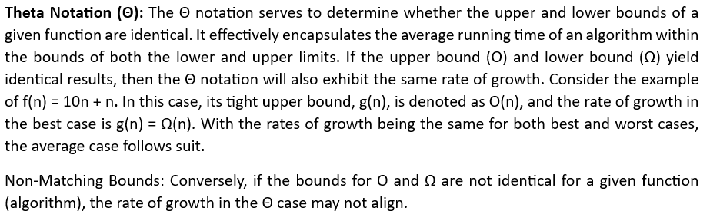
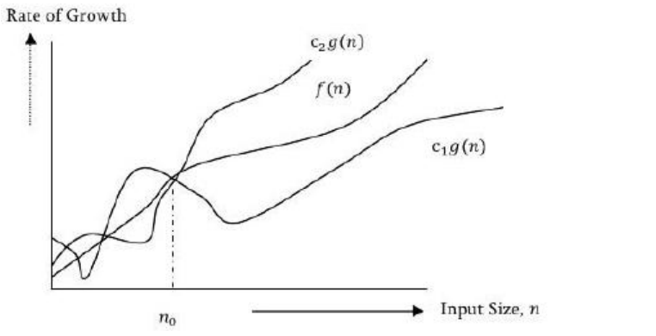
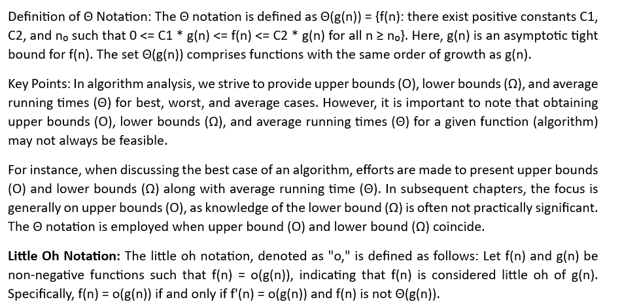
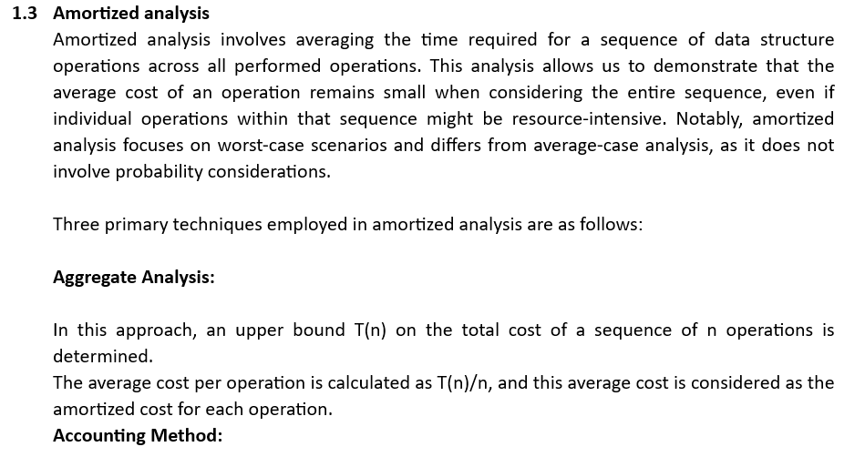
When dealing with multiple types of operations, each operation type may have a distinct amortized cost.
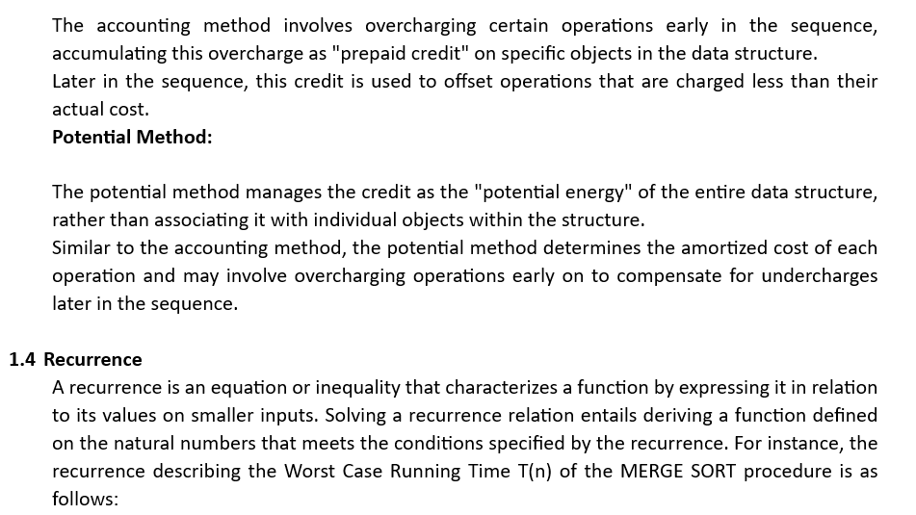
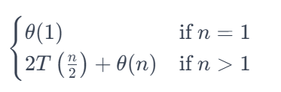
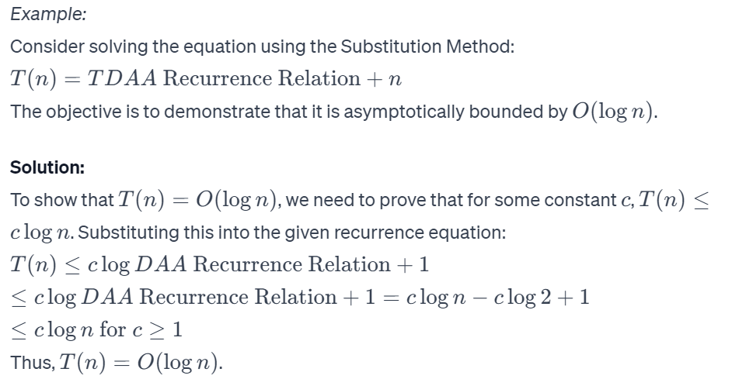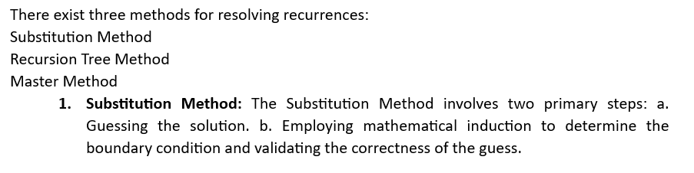

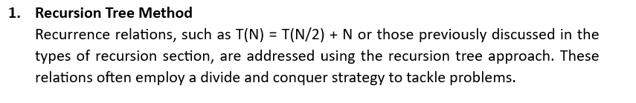
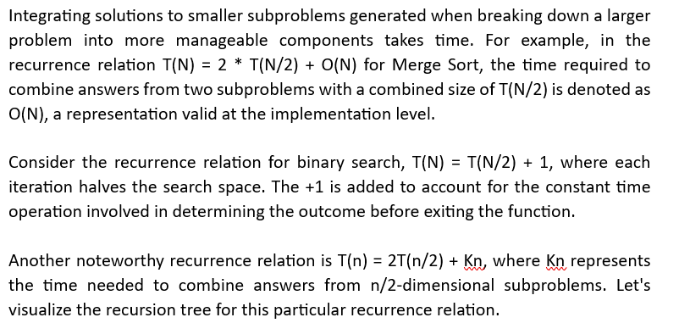
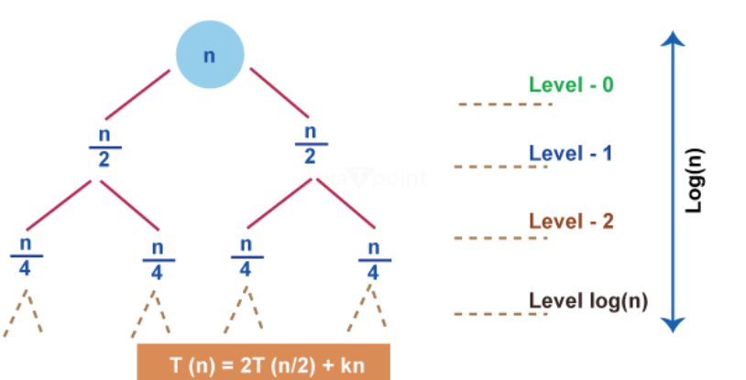
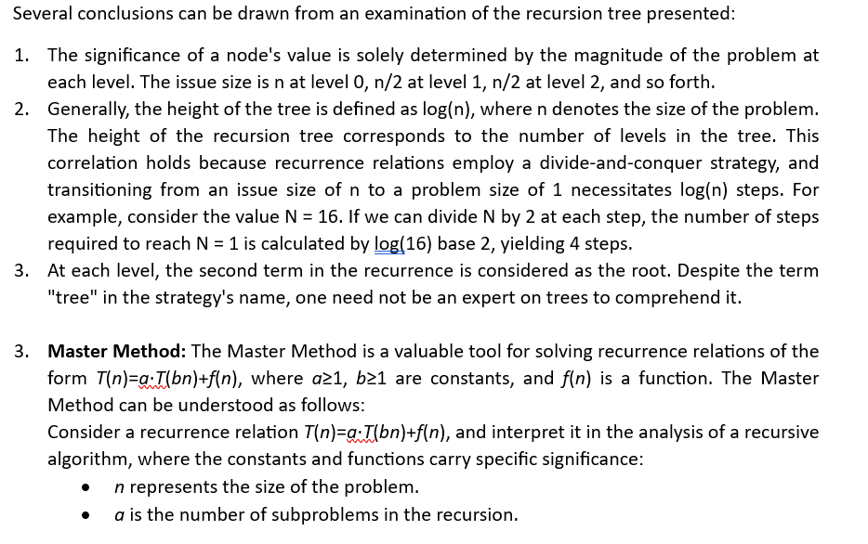

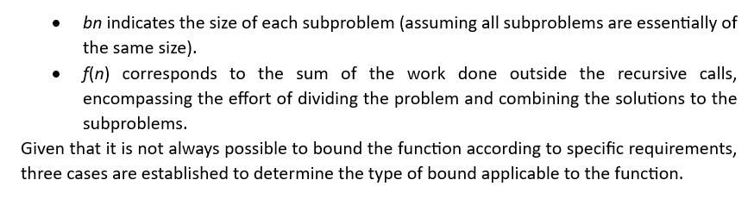

For Numerical examples, solved in a class. Find the below links

Master’s theorem
https://www.youtube.com/watch?v=OynWkEj0S-s

